**A week of mooring activities at the SAEON Egagasini Node**

By: Jethan d’Hotman & Juliet Hermes

April 2015 marked the launch and the inaugral cruise of the Agulhas Systems Climate Array (ASCA) (link to newsletter articles)

In April of this year, the second cruise will take place during which all the moorings and instrumentation will be serviced and the data from the previous year will be downloaded (C2 – D). The ASCA monitoring line will also be extended by 3 tall mooring moorings and 5 CPIES (current, pressure inverted echo sounder; P1 – P5; figure 1). This will ensure that the heat, salt and volume transport throughout the extent of the current will be measured and that any major perturbations that force the current further offshore will be captured



Figure 1: A schematic of the ASCA mooring array through the Agulhas Current

To ensure a successful cruise and a continuation of collaboration between the various institutions involved with ASCA (South African Observation Network (SAEON), Rosenstiel School of Marine and Atmospheric Science (RSMAS), Royal Netherlands Institute for Sea Research (NIOZ), Department of Environmental Affairs (DEA)), SAEON and DEA hosted a cruise planning meeting, technical workshop and a science day. Representatives from NIOZ and RSMAS attended the workshop which was funded by an NRF equipment training grant. The workshop and science day was opened to students and interested parties in the marine community.

**25th January 2016 - Cruise Planning Meeting:**

This meeting was attended by more than 25 delegates, including Prof Lisa Beal (Co-Pi: RSMAS), Dr Juliet Hermes (Co-Pi: SAEON), Dr Borja Aguiar Gonzalez (NIOZ), Dr Chris Duncombe Rae (Co-Pi: DEA) to name a few. It was a crucial meeting to discuss what data and water samples needs to be collected as well as the plans and potential personnel for the April 2016 cruise.

**26th – 28th January 2016 – Technical Workshop:**

The aim of this workshop was to provide a platform for discussions and method sharing between the technicians, students and interns from the US, Netherlands and South Africa.

During the workshop the participants discussed many refining techniques when collecting data, some of these topics were mooring deployment procedures, Conductivity, Temperature and Depth (CTD) profile procedures as well as Ship-borne Acoustic Doppler Current profiler (S-ADCP) correction instrumentation.

**29th January 2016 – Science afternoon:**

On the 29th of January SAEON and DEA hosted up to 50 delegates from the marine science community, including students, industry and scientists, as well as senior management from the NRF and DST for a tour of the mooring fabrication and instrument warehouse and short science presentations by leading scientists. During the tours the delegates were introduced to the basic mooring design and instrumentation, wave gliders, buoyancy gliders and a Current & Pressure Inverted EcoSounder (CPIES).

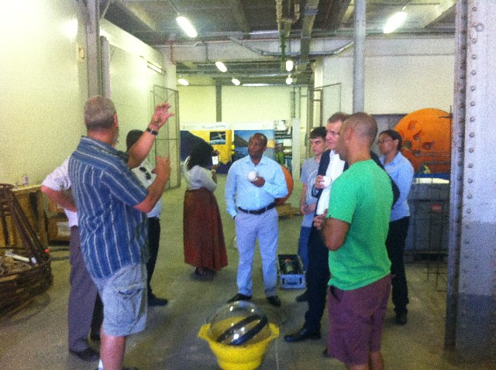

Figure 2: Mr Marcel van den Berg (DEA) explaining to delegates how a basic mooring looks and works

Dr Juliet Hermes (SAEON) and Dr Chris Duncombe-Rae (DEA) introduced the global importance of the oceans surrounding South Africa and the large mooring arrays, as well as the ASCA project and the importance of a long term monitoring array in the Agulhas Current in the context of South African resources.

Prof Lisa Beal (RSMAS) presented her experiences from the Agulhas Current Time series array. She also highlighted the importance of long term monitoring particularly in the Agulhas Current in terms of South African weather, climate and resources.

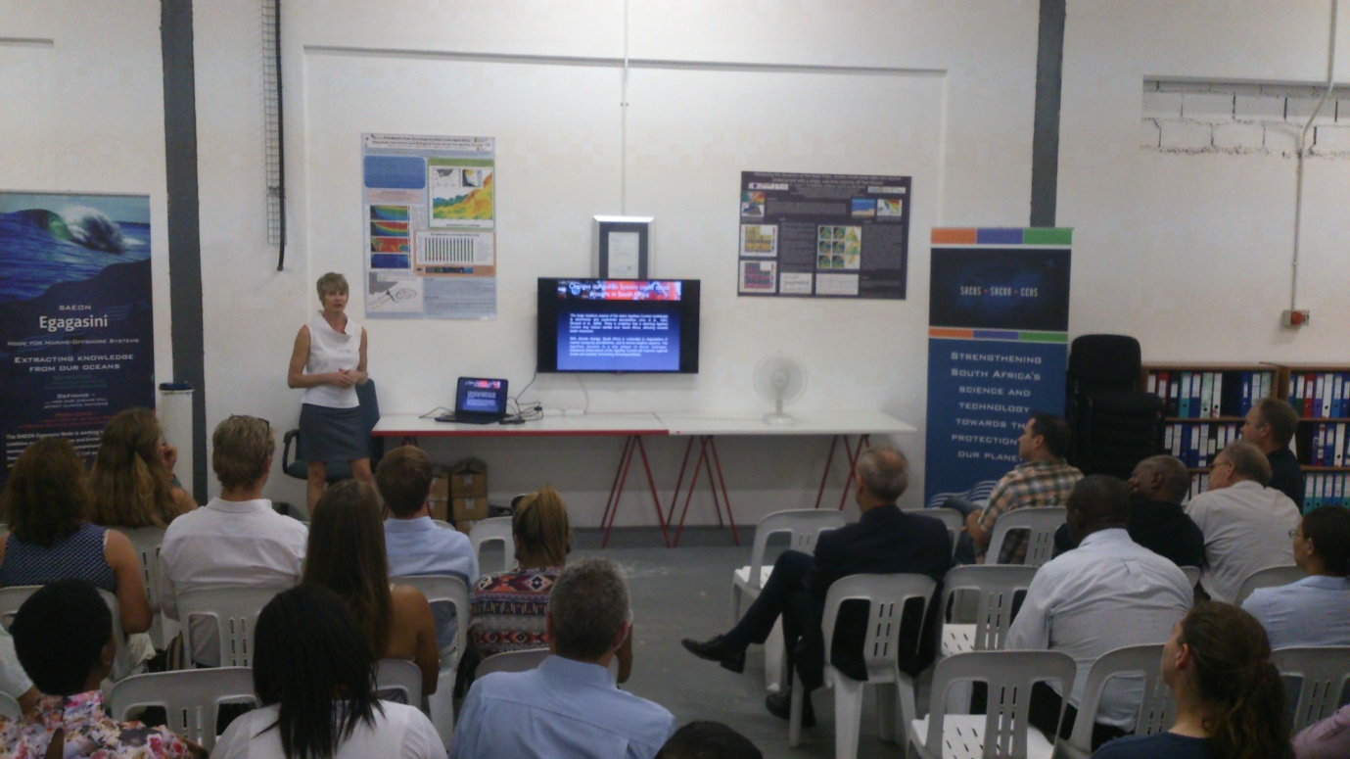

Figure 3: Prof. Lisa Beal sharing her experiences from the ACT array

During the inaugural ASCA cruise Dr Marjolaine Krug and her team deployed two buoyancy gliders in the Agulhas Current (link to SAGE website), Dr Krug showed the difficulty of controlling the gliders in such a strong current. She also showed some exciting preliminary results that will shortly be published.

Mr Kyle Cooper highlighted the importance of long term monitoring arrays for the use of numerical modelling and predicting events and outcomes, particularly for the oil and gas industry, this was of particular importance given the launch of SAMREF the same morning (newsletter article link).

Mr Xolisa Dlomo shared his experience on board the RV Algoa during the inaugural ASCA cruise. He convinced the audience that working at sea can be difficult at times but is extremely enjoyable.

These presentations will be uploaded onto the ASCA website (link)

In all, the week was very successful with many issues and concerns being resolved as well as students learning about the complexities of collecting data in the depths of the ocean.

Tanja Hanekom a student from CPUT said: “There are much more to moorings, as well as the other physical oceanographic equipment, than originally realised. Furthermore, we were taught to not only consider the instrumentation in isolation, but also how to deal with the ocean’s dynamic forces with and on the instrumentation.”